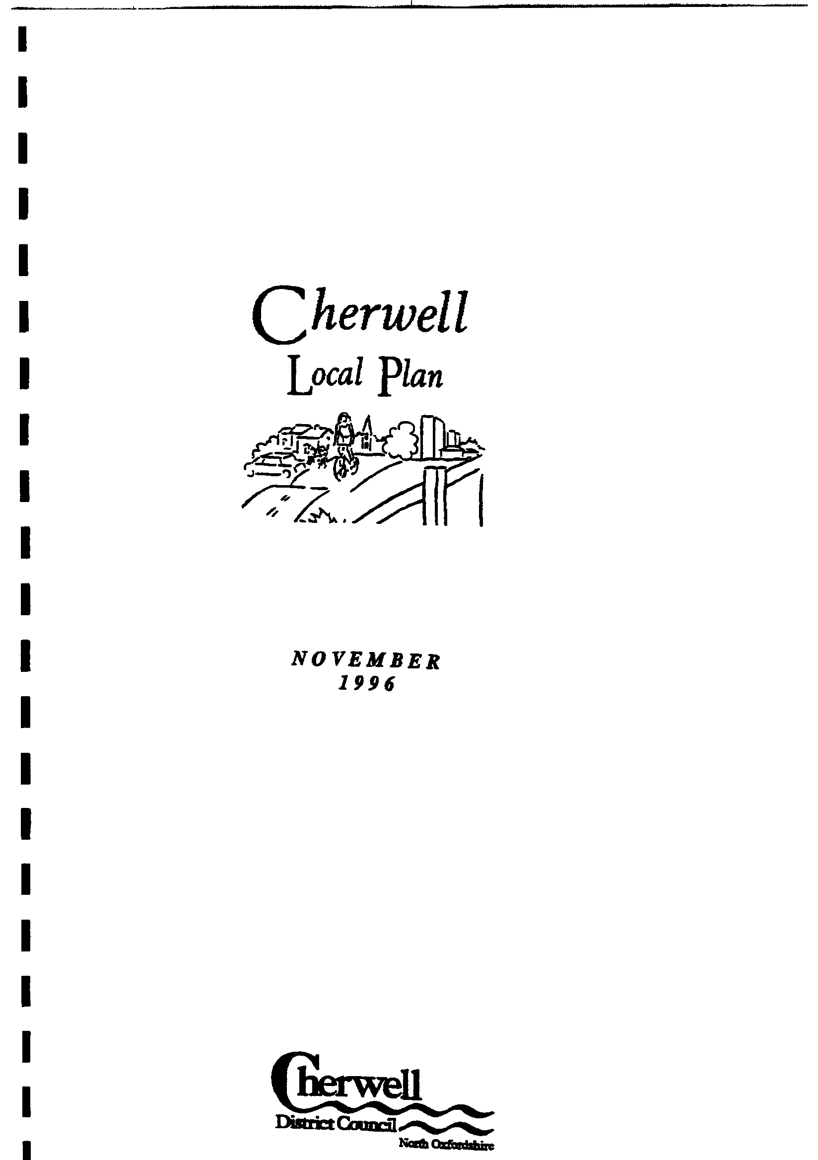
C28 CONTROL WILL BE EXERCISED OVER ALL NEW DEVELOPMENT,
INCLUDING CONVERSIONS AND EXTENSIONS, TO ENSURE THAT THE STANDARDS
OF LAYOUT, DESIGN AND EXTERNAL APPEARANCE, INCLUDING THE CHOICE OF
EXTERNAL-FINISH MATERIALS, ARE SYMPATHETIC TO THE CHARACTER OF THE
URBAN OR RURAL CONTEXT OF THAT DEVELOPMENT. IN SENSITIVE AREAS
SUCH AS CONSERVATION AREAS, THE AREA OF OUTSTANDING NATURAL
BEAUTY AND AREAS OF HIGH LANDSCAPE VALUE, DEVELOPMENT WILL BE
REQUIRED TO BE OF A HIGH STANDARD AND THE USE OF TRADITIONAL LOCAL
BUILDING MATERIALS WILL NORMALLY BE REQUIRED.

C30 DESIGN CONTROL WILL BE EXERCISED TO ENSURE:
C:\Local Plan\C H A P T E R N I N E.doc
(i) THAT NEW HOUSING DEVELOPMENT IS COMPATIBLE WITH THE
APPEARANCE, CHARACTER, LAYOUT, SCALE AND DENSITY OF EXISTING
DWELLINGS IN THE VICINITY;
(ii) THAT ANY PROPOSAL TO EXTEND AN EXISTING DWELLING
(IN CASES WHERE PLANNING PERMISSION IS REQUIRED) IS COMPATIBLE WITH
THE SCALE OF THE EXISTING DWELLING, ITS CURTILAGE AND THE CHARACTER
OF THE STREET SCENE;
(iii) THAT NEW HOUSING DEVELOPMENT OR ANY PROPOSAL FOR
THE EXTENSION (IN CASES WHERE PLANNING PERMISSION IS REQUIRED) OR
CONVERSION OF AN EXISTING DWELLING PROVIDES STANDARDS OF AMENITY
AND PRIVACY ACCEPTABLE TO THE LOCAL PLANNING AUTHORITY.
9.69 The Council wishes to secure environmental enhancement through new development.
Proposals that would detract from the character of an area owing to obviously poor design will
be resisted. Similarly proposals that would change the established character of an area, by, for
example, introducing high-density housing development where low densities predominate, will
normally be unacceptable. The design and layout of new development can also assist with crime
prevention and the Council will have regard to the advice in Circular 5/94 'Planning Out Crime'
and 'Secured by Design' initiative. The assistance of the Thames Valley Policy Architectural Liaison Officer will be sought in this context.
AFFORDABLE HOUSING
2.11 There has been increasing concern in recent years over the provision of affordable
housing to meet local needs. The most recent Government advice on this issue is contained in
"Planning Policy Guidance: Housing (PPG3)" and the subsequent "Draft Explanatory Note on
Planning and Affordable Housing" which describe the role the planning system can play in
enabling such provision to be made.
2.12 The Circular advises that where there is a demonstrable lack of affordable housing, local
planning authorities may negotiate with developers to include an element of affordable housing
in new developments. The following policy is included in view of this advice to encourage
developers to include affordable housing within larger schemes. The policy is designed to be
flexible to accommodate changes in the need for affordable housing which may occur during the
plan period.
H5 WHERE THERE IS A DEMONSTRABLE LACK OF AFFORDABLE HOUSING TO
MEET LOCAL NEEDS, THE DISTRICT COUNCIL WILL NEGOTIATE WITH
DEVELOPERS TO SECURE AN ELEMENT OF AFFORDABLE HOUSING IN
SUBSTANTIAL NEW RESIDENTIAL DEVELOPMENT SCHEMES. THE
DISTRICT COUNCIL WILL NEED TO BE SATISFIED THAT SUCH AFFORDABLE
HOUSING:-
(i) IS ECONOMICALLY VIABLE IN TERMS OF ITS ABILITY TO MEET THE
NEED IDENTIFIED
(ii) WILL BE AVAILABLE TO MEET LOCAL NEEDS LONG TERM THROUGH
SECURE ARRANGEMENTS BEING MADE TO RESTRICT THE OCCUPANCY OF THE
DEVELOPMENT
(iii) IS COMPATIBLE WITH THE OTHER POLICIES IN THIS PLAN.
2.13 At the present time, there is evidence of a lack of affordable housing for local need in
Cherwell District in the main urban areas and in a number of rural settlements. It is envisaged
however that policy H5 will be implemented principally in the urban areas of Banbury and
Bicester, where larger residential development schemes will take place. In particular, large areas
of land north of Hardwick Estate, Banbury and at Slade Farm, Bicester are proposed to be
allocated for residential development, a proportion of which will be encouraged through
negotiation to be developed for affordable housing.
2.14 In addition, a number of unidentified sites within the District may come forward during
the plan period where it would be reasonable for the authority to negotiate for the inclusion of a
proportion of affordable housing. The willingness of a developer to include an element of
affordable housing in such circumstances will be a material consideration in determining a
planning application. However it is not envisaged that the policy would apply to sites less than 1
ha in size, as it would not be reasonable to expect a proportion of affordable housing to be
provided on sites smaller than this.
2.15 Similarly, it is not intended that the policy should apply to those housing sites that were
previously allocated in the Banbury Local Plan Review or the Bicester Local Plan and now have
C:\Local Plan\C H A P T E R T W O.doc
planning permission. Many of these sites have already been acquired by developers on the basis
that the sites have been allocated for general housing available on the open market.
2.16 Evidence of the need for affordable housing to be provided at Banbury, Bicester and
Kidlington has been supplied by the Council's Housing Department. It is estimated that each
year about 100 families who are assessed as being in severe housing need are being added to the
housing waiting list. To this number can be added about 50 families each year who are accepted
as homeless, making a total of 150 families each year. There are no indications that this rate will
fall in future.
2.17 The supply of Housing Association developments on land provided by the Council is
likely to average about 50 dwellings each year for a period of about 3 years after which the
supply of land is likely to be substantially less as the Council exhausts its reserves of land and
seeks to assist Housing Associations by searching for other sites on an ad hoc basis.
2.18 It follows that the need for affordable housing is likely to be approximately 100
dwellings per year in the Council's urban areas. The plan makes provision at Kidlington for local
housing needs to be provided for on the site owned by the Council and referred to in Policy H9.
It is estimated that at least 80 dwellings per annum would be needed at Banbury and Bicester in
total and the 1991 Census shows that 200 households in Banbury and Bicester combined were
sharing accommodation with other households.
2.19 The number of households on the Council's housing list in May 1995 was 778 for
Banbury, 397 at Bicester and 263 at Kidlington. As people are housed from the waiting list, so
the list grows again and there is no apparent end to this cycle.
2.20 Given this background the Council concludes that there is a substantial and continuing
level of affordable housing need in Banbury, Bicester and Kidlington and particularly at
Banbury.
2.21 Accordingly the Council will have as a target in negotiations with developers, the
provision of 20% of new dwellings on sites of 1 ha and over as affordable housing at Banbury
and 15% at Bicester and, should the opportunity arise, at Kidlington.
2.22 The Council recognises, however, that such needs, both in terms of the quantity and type,
as well as site and market conditions are likely to differ in each location and may vary over the
period covered by the plan.
2.23 It therefore, intends to conduct a full housing needs survey of the whole of the District
during the summer of 1995, and to make periodical reviews, and to use the results in negotiations
with developers to seek the provision of an appropriate element of affordable housing on a site
by site basis.
2.24 The definition of what constitutes "affordable housing" is dependent on such factors as
the local housing market, which may vary during the plan period. However affordable housing
will generally be regarded as being housing, whether it be for the outright sale, rent or staircasing
to full ownership, within the financial means of households that are otherwise unable to secure
private sector housing for purchase or rent in prevailing economic circumstances. This is what is
meant by the words "economically viable" in Policy H5(i)".
2.25 The Authority will need to be satisfied of arrangements to ensure that the housing
continues to meet local need in the long term. This is likely to involve management by a housing
C:\Local Plan\C H A P T E R T W O.doc
association or charitable trust. In the case of a site in local authority ownership, this may be
achieved through a local authority and private development partnership scheme.
2.26 Throughout negotiations with developers, the Council will seek to play an active part in
assisting both developers and housing associations in achieving the satisfactory provision of
affordable housing. The Council recognises the key role of Housing Associations in the
provision of affordable housing and believes that they should be registered with the Housing
Corporation so as to ensure that good standards of practice are maintained and so that they are
able to receive full grant aid.

