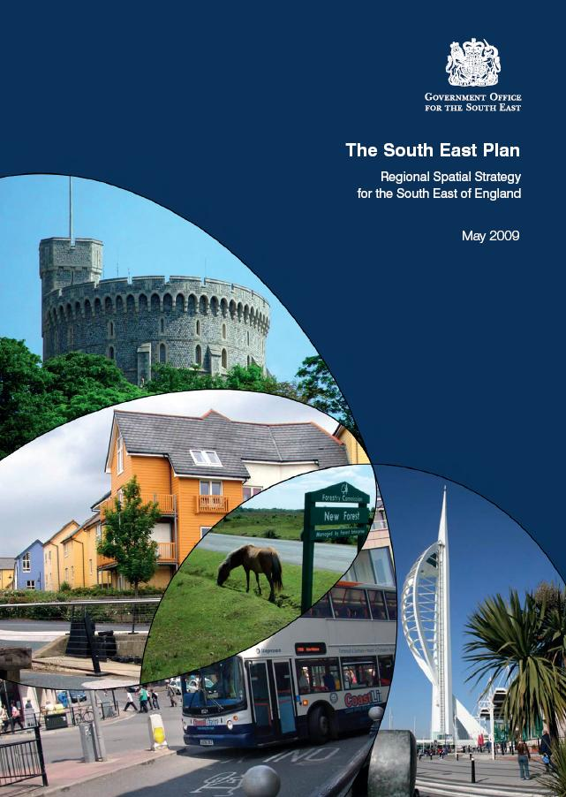

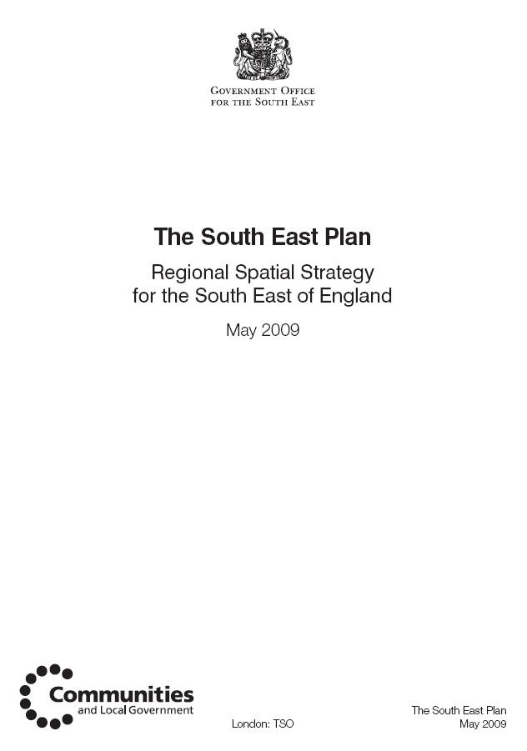

HOUSING: SCALE & DISTRIBUTION
POLICY CO3: SCALE AND DISTRIBUTION OF HOUSING
Local planning authorities will allocate sufficient land and facilitate the delivery of 40,680
net additional dwellings in Central Oxfordshire between 2006 and 2026.
In managing the supply of land for housing and in determining planning applications,
local planning authorities should work collaboratively to facilitate the delivery of the
following level of net additional dwellings in the sub-region:
ANNUAL TOTAL
AVERAGE
DISTRICT
Cherwell (part) 320 6,400
Oxford 400 8,000
South of Oxford SDA 200 4,000 1
South Oxfordshire 412 8,240 2 (part)
Vale of White Horse 512 10,240 3 (part)
West Oxfordshire (part) 190 3,800
Sub-Regional Total 2,034 40,680
At least 40% of all new housing in the sub-region should be affordable, including housing
for key workers.
Development at Cherwell, Oxford and South Oxfordshire should ensure that the national
air and water quality standards are not breached.
Footnotes
Housing provision figures and distributions within districts will be informed by strategic
flood risk assessments, water cycle studies and all other material considerations as
appropriate. The results of these studies will need to be reflected in local development
frameworks and future reviews of the RSS.
1. This represents an allocation for a southern extension to Oxford for the period to 2026.
The apportionment between South Oxfordshire and Oxford City will be determined through
subsequent studies.
2. The figure for South Oxfordshire includes some 6,000 to be located at Didcot.
3. The figure for Vale of White Horse includes 2,750 to be located at Didcot.
Housing provision figures for those parts of each authority not within the sub-region may
be found in the areas outside sub-regions chapter.
22.12 In accordance with Policy CO3, the Central Oxfordshire sub-region will make provision
for 40,680 net additional dwellings between 2006 and 2026; an average of 2,034
dwellings per annum. These figures recognise and reflect regional, economic,
demographic and other local imperatives, the ability of the sub-region to accommodate
at least the numbers proposed, the heritage importance of Oxford, the extent of the
Wessex Downs and Cotswolds Areas of Outstanding Natural Beauty and the existing
pattern/ future delivery of infrastructure. While contributing in due part to the regional
reuse of previously developed land target of 60%, some greenfield development that
includes housing, will be necessary. A selective review of the Oxford Green Belt will be
carried out in accordance with Policy CO4.
22.13 Housing will be distributed as set out in Policy CO3. It is assumed that about 4,900 will
be built at Bicester, about 8,750 at Didcot and about 3,400 at Wantage/Grove. The Vale
of White Horse and South Oxfordshire, via their local development documents (LDDs)
or by other means, will ensure that Didcot’s growth is achieved in a phased and timely
manner within the Plan period. This may include the pooling of resources and/or
development contributions to help deliver any needed transport improvements that
support growth in the wider area or help reduce pressure on the A34.
22.14 . An allocation of 4,000 dwellings for the period up to 2026 is included as part of the
mixed use South of Oxford SDA. The exact location and apportionment will be determined
following more detailed work by South Oxfordshire and Oxford City.
22.15 It will be a matter for the relevant LDDs to respond the figures in Policy CO3. While a
degree of flexibility is associated with these figures, local authorities must in the first
instance seek to deliver their sub-regional allocations within their part of Central
Oxfordshire. Each relevant core strategy development plan document (DPD) within the
sub-region must, therefore, set out a clear distribution, setting out where, when, how
and in what numbers the housing will be developed and, in turn, how this will help deliver
this sub-regional strategy as well as any local vision and strategy. Since the Examination
in Public, the Government has announced that land at Weston Otmoor (Cherwell District)
has been short-listed as a potential eco-town. Policy H2 states that local planning
authorities will need to take account of any proposals for eco-towns arising from the
Government's eco-towns initiative.
22.16 An affordable housing target above the regional average is justified for Central
Oxfordshire. Housing affordability ratios are among the worst in the region; housing
needs surveys indicate affordable housing need exceeds the total amount of new
development proposed; overcrowding and unfit homes are prevalent, particularly within
Oxford, and higher targets already exist in adopted local plans. The indicative target
should therefore be used to guide DPD preparation and development control, and provides
a monitoring benchmark. However, it must be applied with genuine realism, based on
robust evidence such as the results of up-to-date housing market assessments and other
viability work. It must also be applied such that the sub-region contributes in due part to
the delivery of Policy H3. Local development frameworks should also consider how best
to secure suitable accommodation for key workers as part of the achievement of this
target.

Sustainable Development
POLICY CC1: SUSTAINABLE DEVELOPMENT
The principal objective of the Plan is to achieve and to maintain sustainable development
in the region. Sustainable development priorities for the South East are identified as:
i. achieving sustainable levels of resource use
ii. ensuring the physical and natural environment of the South East is conserved and
enhanced
iii. reducing greenhouse gas emissions associated with the region
iv. ensuring that the South East is prepared for the inevitable impacts of climate change
v. achieving safe, secure and socially inclusive communities across the region, and
ensuring that the most deprived people also have an equal opportunity to benefit
from and contribute to a better quality of life.
All authorities, agencies and individuals responsible for delivering the policies in this
Plan shall ensure that their actions contribute to meeting the objectives set out in this
policy and in the Regional Sustainability Framework. (1)
5.1 The principles of sustainable development, as reflected in the Regional Sustainability
Framework (RSF) and the UK Sustainable Development Strategy underpin this Plan. A
cross-cutting policy (CC1) has therefore been incorporated in the Plan to emphasise the
importance of working towards more sustainable development. A clear obligation is
therefore placed on all delivery authorities to demonstrate their commitment through
specific and identifiable actions.

Sustainable Design and Construction
POLICY CC4: SUSTAINABLE DESIGN AND CONSTRUCTION
The design and construction of all new development, and the redevelopment and
refurbishment of existing building stock will be expected to adopt and incorporate
sustainable construction standards and techniques. This will include:
i. consideration of how all aspects of development form can contribute to securing
high standards of sustainable development including aspects such as energy, water
efficiency and biodiversity gain
ii. designing to increase the use of natural lighting, heat and ventilation, and for a
proportion of the energy supply of new development to be secured from decentralised
and renewable or low-carbon sources
iii. securing reduction and increased recycling of construction and demolition waste
and procurement of low-impact materials
iv. designing for flexible use and adaptation to reflect changing lifestyles and needs
and the principle of ‘whole life costing’.
Local planning authorities will promote best practice in sustainable construction and help
to achieve the national timetable for reducing carbon emissions from residential and
non-residential buildings. There will be situations where it could be appropriate for local
planning authorities to anticipate levels of building sustainability in advance of those set
out nationally, for identified development area or site-specific opportunities. When
proposing any local requirements for sustainable buildings, local planning authorities
must be able to demonstrate clearly the local circumstances that warrant and allow this
and set them out in development plan documents.
8 Counting Consumption, World Wildlife Fund and Partners, 2006
Cross Cutting Policies 33
5
The South East Plan - Regional Spatial Strategy for the South East
5.7 Sustainable construction can be defined as creating or renewing buildings so that they
reduce or avoid adverse impacts on the built and natural environment, in terms of the
buildings themselves, their immediate surroundings and the broader regional and global
setting. It is a vital tool in combating climate change and reducing the region's ecological
footprint. Sustainable construction encompasses the following principles:
constructing development to reduce non-renewable resource consumption including
building materials
ensuring development, through its construction and use, reduces the use of energy
and water and protects valuable soil resources
eliminating or minimising the use of toxins and the production of waste associated
with the construction and use of development.
5.8 At the national scale, Government is committed to amending national Building Regulations
to increase energy efficiency in new buildings.(9)It has outlined a timetable to achieve a
20% reduction in carbon emissions from new homes by 2010, and nearly 50% by 2013,
before reaching zero carbon in 2016. It announced in the 2008 Budget an ambition for
all new non-domestic buildings to be zero carbon from 2019. The Government has also
indicated its intention to bring forward an amendment to the Building Regulations to
include a requirement for a minimum standard of water efficiency in new homes from 1
October 2009 and will review the Water Supply (Water Fittings) Regulations 1999 later
in 2009.(10)The Code for Sustainable Homes - a new national standard for sustainable
design and construction of new homes also now operates. Since April 2007 the developer
of any new home in England could choose to be assessed against the Code, and rating
against the Code has been mandatory since May 2008. It replaces the EcoHomes
scheme, developed by the Building Research Establishment. For non-residential buildings,
a number of sustainability assessment tools are well established and should be used
throughout the region. For waste, Site Waste Management Plans became a legal
requirement from April 2008, and require better management of waste on construction
and development sites to improve materials resource efficiency.
5.9 The use of sustainability checklists, such as those promoted by Climate Change South
East and SEEDA can help deliver new homes that outperform the existing stock in terms
of efficiencies in resource use.
5.10 Progress is being made – for example, work to support the setting of zero-carbon targets
in Milton Keynes, including the development of low carbon emitting housing on sites
such as Oxley Wood, and the deployment of decentralised energy systems by Woking
Borough Council. Local authorities are ideally placed to identify where place-specific
opportunities may arise to improve energy and water efficiency and promote lower
emissions. Planning Policy Statement: Planning and Climate Change (PPS1 Supplement)
confirms that it could be appropriate for local planning authorities to expect higher levels
of building sustainability than the standards in national Building Regulations. Local
requirements should be brought forward through development plan documents and focus
on known opportunities, with local authorities demonstrating clearly the local
circumstances that warrant and allow local requirements. An example is where higher
standards of water efficiency would make development in areas of water stress more
sustainable. Any local requirements should be specified in terms of the achievement of
nationally described sustainable buildings standards. Local authorities also have duties
under the Home Energy Conservation Act to improve the energy efficiency of housing
stock and there is also considerable scope to improve the efficiency of current public
buildings through retrofitting.
5.11 The Government's water strategy for England, Future Water, was published in February
2008. It sets out the long-term vision for water and the framework for water management
in England. This includes an ambition to reduce per capita consumption of water, through
cost-effective measures, to an average of 130 litres per person per day (l/p/d) by 2030.
9 Building a Greener Future, Department for Communities and Local Government, July 2007, and Water Efficiency in
New Buildings – A Consultation Document,Department for Communities and Local Government, Department for
Environment, Food and Rural Affairs, December 2006.
10 http://www.communities.gov.uk/publications/planningandbuilding/water-efficiency
34 Cross Cutting Policies
5
The South East Plan - Regional Spatial Strategy for the South East
5.12 The Government has set out its programme for introducing water efficiency standards
through the Building Regulations and the Code for Sustainable Homes. In particularly
water-stressed areas, local planning authorities may seek higher standards for water
efficiency than those set nationally, through their local development frameworks. This
will need to be proportionate and evidence based, and will be tested through the planning
process.
5.13 Other ways of reducing water efficiency in line with Future Water include:
water metering - Water company customers who are metered typically use 10%
less water than other customers. All new build is fitted with water meters and water
companies in the South East are looking at strategies for existing property. Some
companies, such as Folkestone and Dover Water Services Ltd, are already
undertaking programmes of metering for all properties, whilst Thames Water is
undertaking metering pilots. Southern Water has proposed, in its draft Water
Resources Management Plan, to introduce compulsory metering for all properties
by 2015; and Portsmouth Water has announced its intention to meter all customers
starting in 2010. The Southern Water and Portsmouth Water proposals for metering
are dependent on the Secretary of State for the Environment, Food and Rural
Affairs being satisfied that the options appraisals in the plans support metering as
a cost effective solution to ensuring a sustainable supply of water.
water efficiency targets – Ofwat have introduced water efficiency targets for water
companies for the period 2010 – 2015. The new targets will require water companies
to undertake activities to meet annual minimum water saving targets of 23 million
litres per day across all water companies.
review of the Water Fittings Regulations – A review of Water Fittings Regulations
is taking place in 2009. The Water Supply (Water Fittings) Regulations will be
revised with a view to setting new performance standards for key water using fittings
such as WCs, urinals, dishwashers and washing machines. These measures will
apply to individual appliances installed in both new and existing houses and
non-domestic buildings and are intended to complement the overall performance
standard set within the Building Regulations.
5.14 Policies NRM 11-16 contain a more detailed approach to the deployment of renewable
energy technologies in the region.

Sustainable Communities and Character of the Environment
POLICY CC6: SUSTAINABLE COMMUNITIES AND CHARACTER OF THE ENVIRONMENT
Actions and decisions associated with the development and use of land will actively
promote the creation of sustainable and distinctive communities. This will be achieved
by developing and implementing a local shared vision which:
i. respects, and where appropriate enhances, the character and distinctiveness of
settlements and landscapes throughout the region
ii. uses innovative design processes to create a high quality built environment which
promotes a sense of place. This will include consideration of accessibility, social
inclusion, the need for environmentally sensitive development and crime reduction
5.18 The South East has a high quality environment with a rich heritage of historic buildings,
landscapes and habitats. This is reflected in the coverage of protective designations and
contributes to the region’s identity and the quality of life residents and visitors enjoy. It
is also subject to a high degree of development pressure. Forward planning must therefore
actively seek to promote sustainable communities whilst protecting and, wherever
possible, enhancing these valuable assets and their contribution to the sustainable
development of the region in the long term.
The Government’s vision for Sustainable Communities is set out in its ‘Homes For All’ Five Year
Plan.(13) Sustainable communities are defined as:
active, inclusive and safe
well run
12 Ageing Assets Implications of Population Ageing for the South East Region, Population Ageing Associates for the Social
Inclusion Partnership for the South East, October 2005
13 Five Year Plan, Sustainable Communities for All, Department for Communities and Local Government, January 2005
36 Cross Cutting Policies
5
The South East Plan - Regional Spatial Strategy for the South East
environmentally sensitive
well designed and built
well connected
thriving
well served
fair for everyone.

Sustainable Flood Risk Management – Making Space for Water
POLICY NRM4: SUSTAINABLE FLOOD RISK MANAGEMENT
The sequential approach to development in flood risk areas set out in PPS25 will be
followed. Inappropriate development should not be allocated or permitted in flood zones
2 and 3 (Diagram NRM1), areas at risk of surface water flooding (critical drainage areas)
or areas with a history of groundwater flooding, or where it would increase flood risk
elsewhere, unless there is over-riding need and absence of suitable alternatives.
Local authorities, with advice from the Environment Agency, should undertake a Strategic
Flood Risk Assessment (SFRA) to provide a comprehensive understanding of the flood
risk and put in place a framework for applying the PPS25 sequential approach. This will
88 Natural Resource Management
9
The South East Plan - Regional Spatial Strategy for the South East
facilitate allocating sites in a decreasing probability of flood risk. The SFRA would assess
future climate change and identify appropriate types of development in accordance with
the PPS25 sequential test and flood vulnerability of different land uses.
Existing flood defences will be protected from development. Where development is
permitted in appropriately defended floodplains it must be designed to be resilient to
flooding (to minimise potential damage) and to allow for the future maintenance,
realignment or management of the defences to be undertaken.
In the preparation of local development documents and considering planning applications,
local authorities in conjunction with the Environment Agency, should also:
i. take account of River Basin Management Plans, Catchment Flood Management
Plans, Shoreline Management Plans and Surface Water Management Plans in
developing local development documents and other strategies. Where locationally
specific flood risk and land management options such as flood storage, managed
realignment and set back from coastal defences are identified, land should be
safeguarded for these purposes and appropriate land use and land management
practices should be encouraged
ii. consider the associated social and environmental costs and benefits to fisheries,
biodiversity and the built and historic environment in assessment of new flood
management schemes
iii. require incorporation and management of Sustainable Drainage Systems (SuDS),
other water retention and flood storage measures to minimise direct surface run–off,
unless there are practical or environmental reasons for not doing so
iv. take account of increased surface water drainage on sewage effluent flows on fluvial
flood risk.
9.11 The South East has a particularly wide ranging flood risk management challenge with
an extensive area at risk of flooding, due to coastal, tidal, fluvial, groundwater and surface
run-off flood risk. The probability of flooding can be reduced through the management
of land, river systems and flood defences, and the impact reduced through influencing
the type of development in flood risk areas, flood warning and emergency responses.
9.12 To adapt to climate change we must design and locate new development with flood risk
in mind, and we must plan to make more space for water through better management
of land for water storage and flood protection.
9.13 Over 208,000 properties in the South East have been identified as being within an area
where there is high probability of flooding. (4) Zones are defined in Planning Policy
Statement 25: Development and Flood Risk and are set out on the Environment Agency’s
Flood Zone map (see Diagram NRM1). This information will be used as a starting point
to develop strategic flood risk assessments and inform local development decisions. The
Environment Agency has also produced a flood map that takes account of the presence
and standard of flood defences in these flood zones.
4 Environment Agency, State of the Environment Report, South East England, 2007
Natural Resource Management 89
9
The South East Plan - Regional Spatial Strategy for the South East
9.14 PPS25 recommends a precautionary sequential approach to allocation and permitting
of sites for development, avoiding areas of highest risk (zone 3) where possible. However,
a degree of flexibility will be needed to consider the relative severity of flood risk and, in
some instances, accepting the need to live with some level of flood risk, designing
development to reduce the risk and minimise the impact of flooding.
9.15 The probability and impacts of flooding can be reduced through:
i. applying the sequential test set out in PPS25
ii. ensuring that an appropriate Strategic Flood Risk Assessment (SFRA) is carried
out for developments or plan allocations in flood zones 2 and 3. This includes those
areas benefiting from defences of an appropriate standard. The assessment must
also address impacts of climate change and the policies of Catchment Flood
Management Plans (CFMPs) or Shoreline Management Plans (SMPs), and avoid
foreclosing options for realignment and management of defences to reinstate natural
floodplains. Further guidance on flood resilience is available from sources including
the Association of British Insurers. (5)
iii. ensuring development does not worsen flooding in its surroundings, through use
of appropriate sustainable drainage systems (SuDS) to help reduce the likelihood
of flooding and pollution by controlling surface water run off. Where possible multiple
benefits, including for recreation and wildlife, should be delivered. In considering
SuDS solutions, the need to protect ground water quality must be taken into account,
especially where infiltration techniques are proposed. Proposals must include an
agreement on the future management, maintenance and replacement of these
structures. A range of SuDS techniques is listed in the box below. Further guidance
is available from the National SuDS Working Group
iv. encouraging positive flood risk management by changing farming and forestry land
management practices. This is especially important where it would directly contribute
to the delivery of CFMP objectives, enhance biodiversity and amenity, or mitigate
the impact of urban development on the water environment.
5 www.abi.org.uk
90 Natural Resource Management
9
The South East Plan - Regional Spatial Strategy for the South East
9.16 CFMPs aim to achieve the most effective management of flood risk (probability and/or
consequence), against a background of increasing flood probability. They provide broad
policies and provide prioritised actions which take a whole river catchment approach to
flood risk management and should be reflected in LDDs.
Sustainable Drainage Systems
permeable surfaces – allowing infiltration of rainwater into the underlying construction or
soil
filter drains/strips – linear features which store and conduct water but may also permit
infiltration
swales – shallow vegetated channels constructed to conduct or store rainwater, often from
roads/paved areas, possibly also allowing infiltration
basins, ponds and wetlands – providing storage for surface water run off and infiltration.
These may be designed to be dry at some points of the year
soakaways – below ground structures designed to promote the infiltration of surface water
to ground
Infiltration trenches – linear structures, usually filled with granular material designed to
promote the passage of surface water to ground. These techniques may not be appropriate
in certain areas due to the vulnerability of groundwater
rainwater re-use – the harvesting/collection of rainwater from roofs and hard standing for
non-potable uses. Unlike greywater, rainwater may not require treatment to allow it to be
stored
green roofs – planted roof areas where the vegetated area provides a degree of retention
and treatment of water and promotes evapotranspiration

